**PYCITY SCHOOLS ANALYSIS**

PyCity Schools analysis was made of two datasets; Students data and School data. The data sets entailed 15 Schools and 39170 students respectively.

**Findings**

1. **School Type**

Charter schools out-performed the public district schools across all metrics. However, more analysis will be required to ascertain if the effect is due to school practices or the fact that charter schools tend to serve smaller student populations per school.

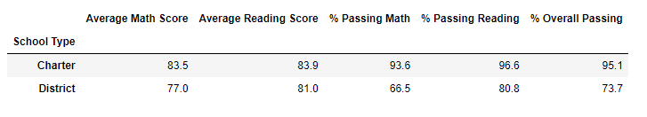

Summary of highest performing Schools

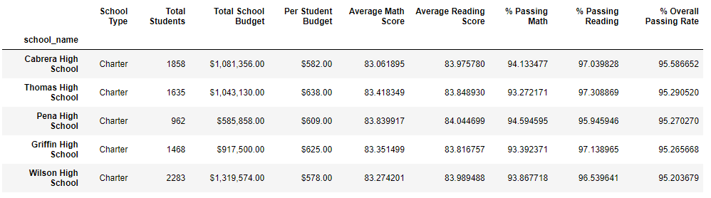

Summary of bottom performing Schools

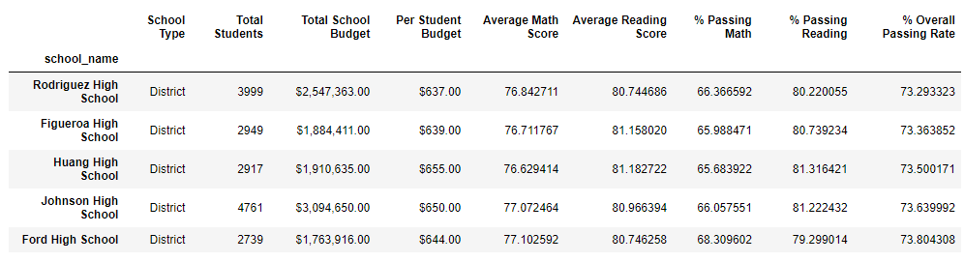

1. **School Spending per student**

Schools with higher budgets, did not yield better test results. Notably, schools with higher spending 645-675 per student actually underperformed compared to schools with smaller budgets (585 per student).

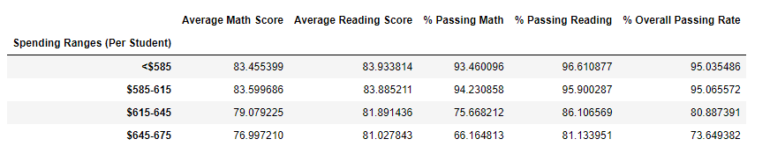

1. **School Size**

Smaller and medium sized schools out-performed large sized schools especially on math performances (Above 90% passing vs 69.9%) as indicated below.

